**Software Requirement Specification**

**(SRS)**

**Event management web application**

**Version: 1.0 Date:21-5-2023**

**Prepared By-**

**Md. Farzine Hosssen**

**Reg:- 2020831007**

**1. Requirements from the client description with appropriate user roles and their functionality:**

Based on the client description, let's outline the requirements for the Event Management Web Application with appropriate user roles and their functionalities:

**1. User Roles:**

a. Event Planner/Organizer: Responsible for creating and managing events.

b. Attendee/Participant: Users who register for events and attend them.

c. Vendor/Service Provider: Offers event-related services, such as catering, photography, etc.

d. Admin: Manages the overall application, user roles, and system settings.

**2. Event Planner/Organizer Functionality:**

a. Create and manage events by specifying event details, such as date, time, location, and ticketing options.

b. Customize event registration forms and ticket prices.

c. Track event planning progress, assign tasks to team members, and manage event agendas.

d. Promote events through customizable landing pages, email invitations, and social media integration.

e. Manage attendee information, send event updates, and collect attendee feedback.

f. Access analytics and reports on registration numbers, ticket sales, and attendee satisfaction.

**3. Attendee/Participant Functionality:**

a. Register for events and purchase tickets securely.

b. Receive automated confirmations and digital tickets for easy check-in.

c. Access personalized event information, including schedules, speakers, and session details.

d. Provide feedback and complete event surveys.

e. Communicate with event organizers for inquiries or assistance.

**4. Vendor/Service Provider Functionality:**

a. Create a vendor profile and list services offered.

b. Browse and apply for event partnership opportunities.

c. Communicate with event organizers for collaboration and negotiation.

d. Receive event-specific requirements and updates.

e. Track service requests and manage event bookings.

**5. Admin Functionality:**

a. Manage user roles and permissions.

b. Monitor and moderate event listings and vendor profiles.

c. Generate reports and analytics on system usage and event performance.

d. Configure system settings, such as payment gateway integration and email notifications.

e. Provide technical support and assistance to users.

**2. Additional requirements:**

Here are some additional requirements that may consider adding to the Event Management Web Application:

**1. Integration with Third-Party Services:**

The application should integrate with popular third-party services such as email marketing platforms, payment gateways, social media platforms, and CRM systems to enhance functionality and provide a seamless experience for users.

**2. Event Feedback and Rating:**

Incorporate a feedback and rating system that allows attendees to provide post-event feedback and rate their experience. This feature helps event organizers gather valuable insights and improve future events.

**3. Customizable Event Websites:**

Enable event organizers to create custom event websites within the application, allowing them to showcase event details, agendas, speakers, sponsors, and other relevant information. This feature enhances branding and marketing efforts.

**4. Sponsor and Exhibitor Management:**

Provide a dedicated module for event organizers to manage sponsors and exhibitors. This includes features such as sponsor/exhibitor registration, booth allocation, payment processing, and communication tools.

**5. Session and Agenda Management:**

Allow event organizers to create and manage event sessions, including keynote speeches, workshops, breakout sessions, and networking activities. Provide features for scheduling, speaker management, and attendee registration for specific sessions.

**6. Surveys and Polls:**

Implement surveys and polls functionality to gather attendee feedback and preferences before, during, and after the event. This feature helps event organizers make data-driven decisions and tailor future events to meet attendees’ expectations.

**7. Mobile Application Integration:**

Develop a companion mobile application that seamlessly integrates with the web application. This allows attendees to access event information, receive notifications, network with other attendees, and participate in interactive activities.

**8. Multilingual Support:**

Provide multilingual support to cater to a diverse audience. Allow users to switch between languages and provide event content, registration forms, and communication in multiple languages.

**9. Accessibility Features:**

Ensure the web application meets accessibility standards, including support for screen readers, keyboard navigation, and alternative text for images, enabling individuals with disabilities to access and use the application.

**Here’s the UML Use Case Diagram for Event Management Web Application**

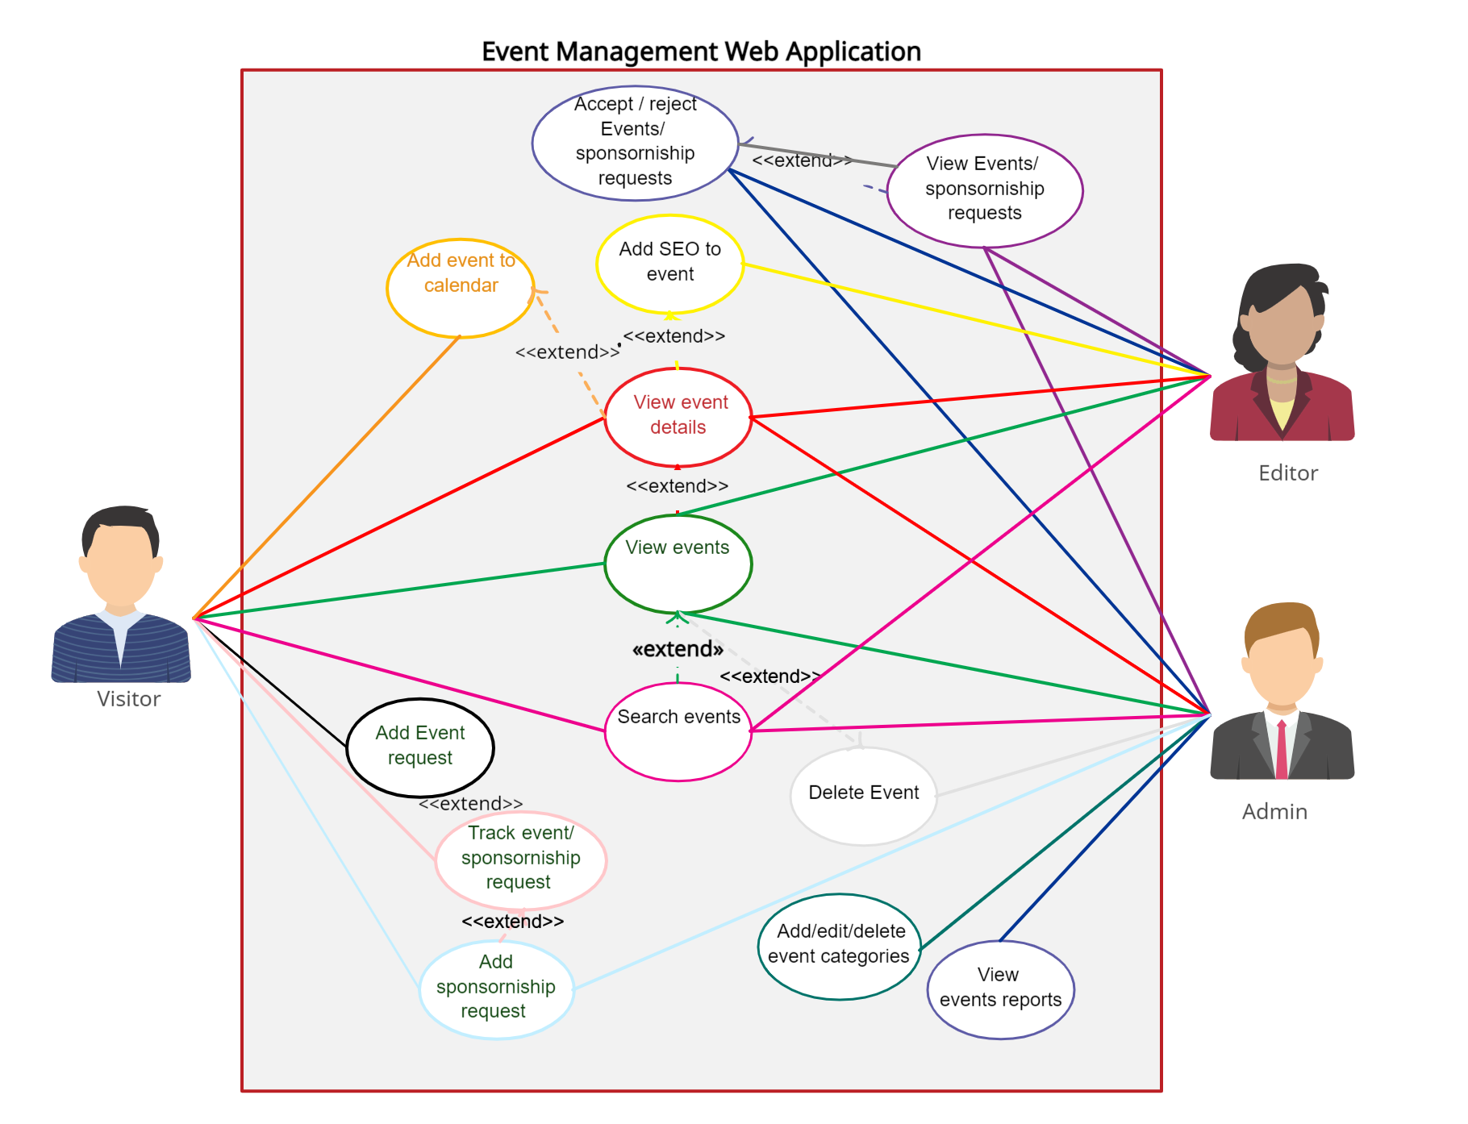**Here’s the UML Activity Diagram for Event Management Web Application**

**Create**

**?**

Event information

Add event tab

Select Date and Time

My Calendar Tab

Event Selection

Event List Tab

no

View Specific Event

Search

no

View event details

Save?

update

View events

no

Edit Event form

edit events

Cancel?

Cancel Event

**Yes**

Save

Yes